**Actors of the system:**

1. Operator
2. Admin
3. Customer (Secondary user to some extent if we extent it to online ordering)

**Basic Requirements**

1. Admin login
2. Operator login
3. Remove items, promotions, deals, operators, customer (by admin)
4. Add items ,promotions, deals, operators (by admin)
5. Add customer and sales (by operator)
6. Update items, promotions, deals, operators (by admin)
7. Search for item, sale, and customer.
8. Make bill in PDF format.
9. Make graph based on information in Databases.
10. Database having Admin, customer, sales and operator information

**More Requirements:**

1. Regular customer details(some sort of ID number)
2. Multiple search type either ID, Date, Name
3. Create new employee(waiter, operator)
4. Discount log maintenance
5. Create user (admin)
6. Printer linking and usage
7. Graph features i.e. top products, top customers, daily weekly and monthly sales record
8. Display of statistics every time.

**Non- Functional requirements**

1. Password Type
2. Online Order
3. Email based or phone number based logins
4. Deals type(daily, weekly, monthly)
5. Determine user type(admin/operator)
6. Graph type i.e. pie, bar etc.
7. Tax bar

**High Risk Elements**

1. Cancellation of order
2. Updating order
3. Late Order

Cancellation/updating of order will cause an error in system where you have no chance other than to cancel it will cause financial as well as system error. The system show the sale but actually it is not.

**Solution**:

We set a timeout after order in between that time user can change its decision and the order will be started to be prepared.

Late order will be dealt in the agreements and rules.

**Addressing Most Critical Use Cases**

**Fully dressed Use Cases**

**Login**

**Actor**: Operator and Admin

**Stack Holder**: Operator or Admin

**Precondition**: There must be an account of the user (admin/operator)

**Post** **Condition**: User successfully logged into the system.

**Main Success Scenario**: User start the system and enter its credentials. The system checked in its data base to verify its credentials. And message printed user successfully logged in.

**Extensions**: Credentials are incorrect and not logged inn.

**Special Requirements:** GUI

--

**Add Customer**

**Actor**: Operator

**Stack holder**: Operator want to enter the customer features to its list of customer in system.

**Interests**: Owner of the Fast food get new customer more business more profit.

**Pre-Condition**: Operator has an account and must have login before add customer.

**Post-Condition:** Customer successfully added to the system and updated in customer list.

**Main Success Scenario:** A customer arrived for buy/order the food, operator validate him, but he found he is new customer. Operator enter his/her credentials into the system and submit to system that he update it. A new customer account been created and issued a card/ID to customer.

**Extensions:** Customer is already registered or has credentials insufficient.

**Special Requirements:** Separate UI.

--

**Take Order**

**Actor:** Operator

**Stack Holders:** Operator wants to enter the items of order from customer.

**Interests:** Owner

**Pre-Conditions:** Operator have a login ID and successfully logged to the system and customer must be in the customer list.

**Post-Conditions:** Order successfully placed and an auto generated receipt of the order created.

**Main Success Scenario:** Customer came to place his/her order. Operator asked about regular or first time customer. Customer if regular he will give his/her ID, and if the ID valid. The operator start to place his/her order and add his items of interest. At the end of submission the total amount to pay will be shown to customer. Customer pay the amount and wait for the order.

**Extensions:** Customer is not valid or new customer than the order may not be placed. If he did not have the total amount to pay also order must be cancelled.

**Special Requirements:** GUI which shows Items added of order.

**--**

***Cancel Order***

**Actors:** Operator

**Stack Holders:** Operator want to cancel the order of the person with in due time on the concern of Customer.

**Interests:** Customer

**Pre-Conditions:** There must be an order placed by customer.

**Post-Conditions:** The customer order easily cancelled by operator.

**Main Success Scenario:** Customer ordered the food. For the time being i.e. in time limit he want to cancel his/her order may be time issue or anything else. Operator check his her order and cancel the order of the customer.

**Extensions:** No order is placed and the time limit is exceeded.

**Special Requirements:** No

**--**

**Use case Diagram**

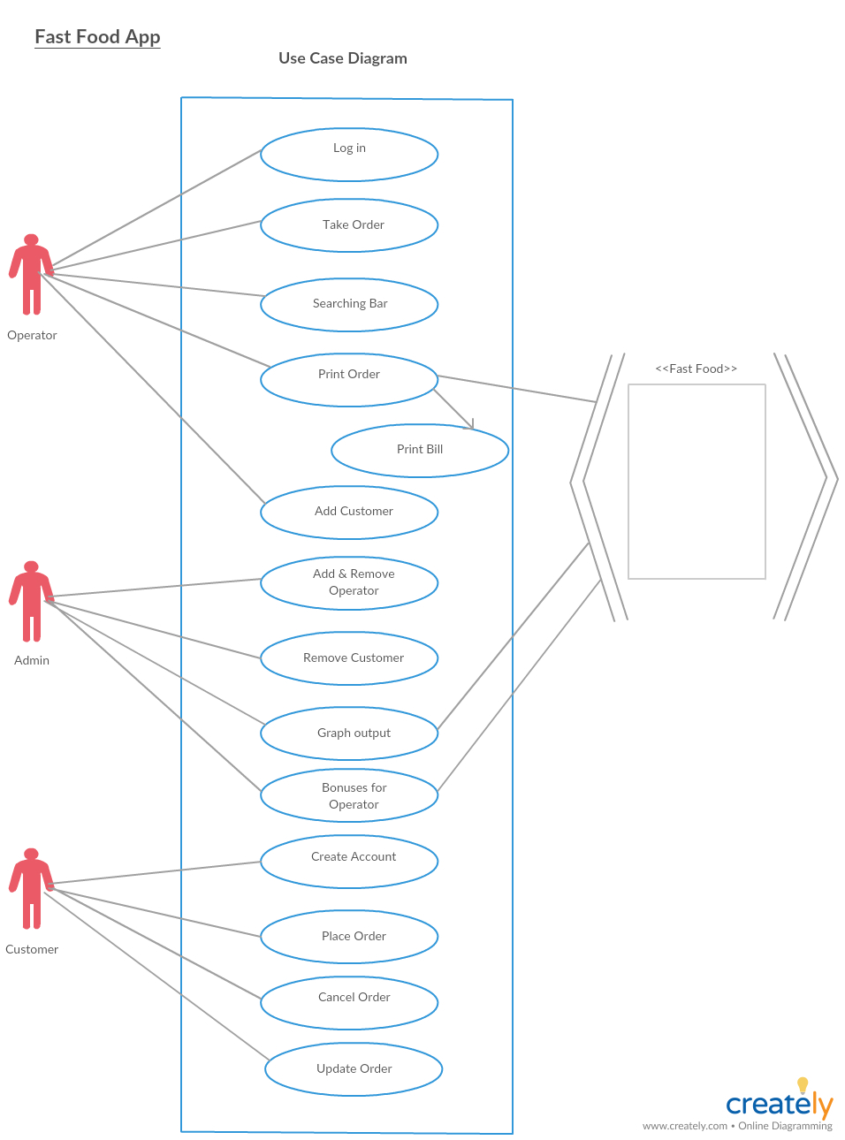

**Domain Model**

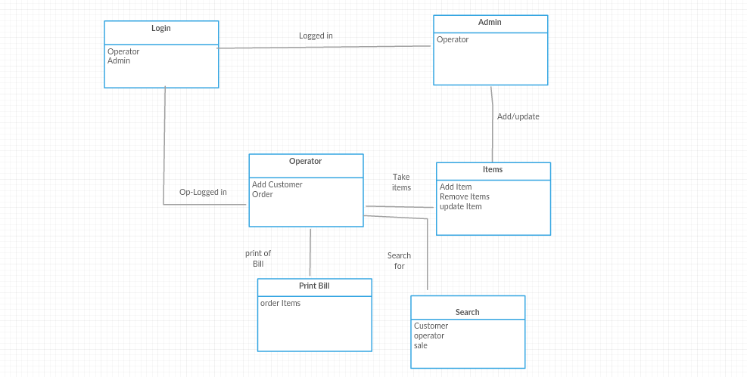

**Elaboration Phase: Iteration 2 Plan**

In next iteration we will make class diagram, and data model (database) and implementation of high risk use cases.